### **Analysis of Airbnb’s Initial Concept vs. Current Reality**

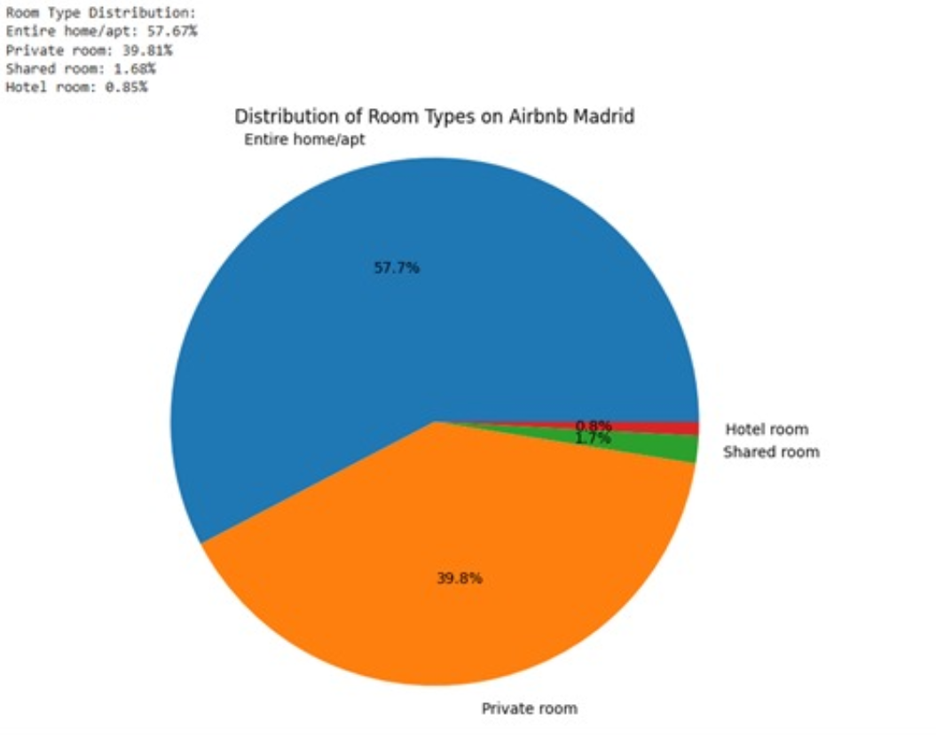

#### **Airbnb’s Original Concept:**

* Airbnb started as a platform for homeowners to rent out a room or shared space inside their homes.
* The idea was to offer affordable accommodation while allowing hosts to earn extra income.

#### **Current Reality Based on Data:**

1. **Major Shift to Entire Homes & Apartments**
   * **57.7% of listings are now entire homes or apartments** (compared to shared spaces or private rooms).
   * This suggests that Airbnb has significantly moved away from its original model of renting out a spare room.
2. **Private Rooms Are Still Significant**
   * **39.8% of listings are private rooms,** indicating that the original concept is still relevant but no longer dominant.
3. **Shared Rooms Are Rare**
   * **Only 1.67% of listings are shared rooms,** showing that the "couch-surfing" style offering has almost disappeared.
4. **Emergence of Hotel Rooms**
   * **0.85% of listings are hotel rooms,** suggesting that even traditional hospitality businesses are using Airbnb as a distribution channel.

#### **Insights & Takeaways:**

* **Airbnb has evolved into a mainstream lodging platform** competing with hotels and vacation rentals rather than just a home-sharing service.
* The dominance of entire homes indicates a shift toward **investment-driven hosts**, rather than casual homeowners renting out spare rooms.
* The presence of hotel listings signals **Airbnb's broader acceptance by the hospitality industry** and its growing role in professional accommodations.